(6) let them marinate , covered and chilled **for 4 hours or over night .**

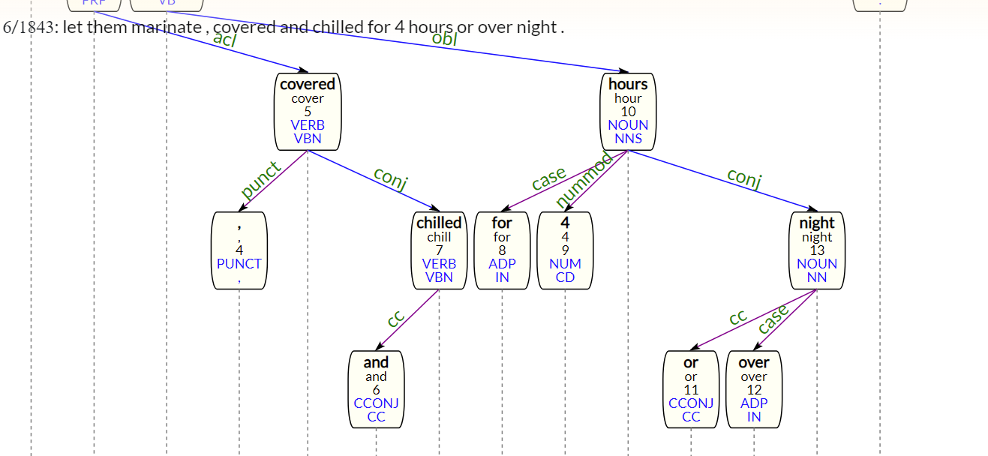

(7) arrange the wings , **skin side up (obl),** on the rack of a foil lined large broiler pan and bake them in the upper third of a preheated 425f oven **for 25 to 30 minutes or until they are golden . (golden -advcl-> bake)**

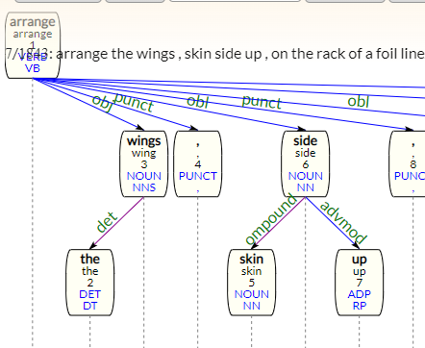

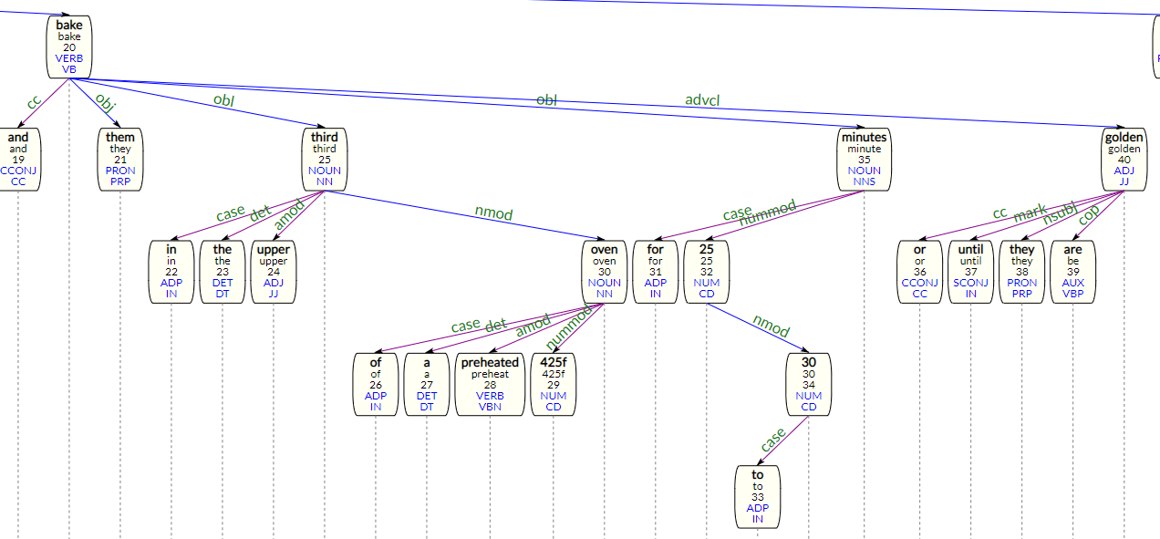

(11) stir in pineapple , green pepper and onion , **set aside . (parataxis)**

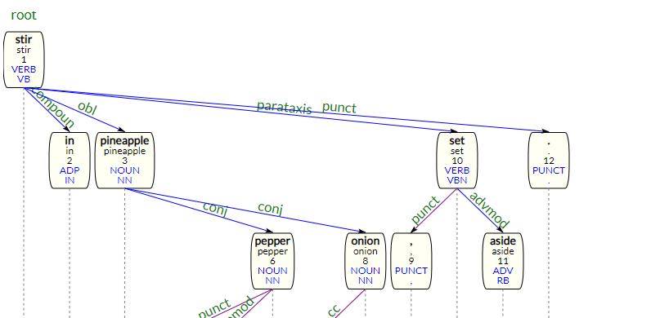

(16) cover and simmer over low heat **15 minutes . (obl, not obj) (Perhaps I should have used obl:tmod instead of obl)**

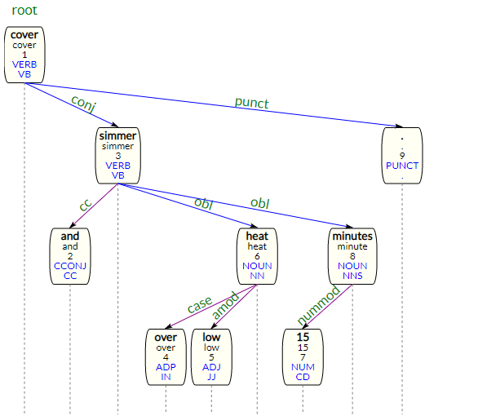

(24) continue roasting pork for calculated cooking time , basting pork **every 15 mins** (obl?) with coffee mixture . (I’m not 100% sure about this. Need to double-check the UD guidelines)

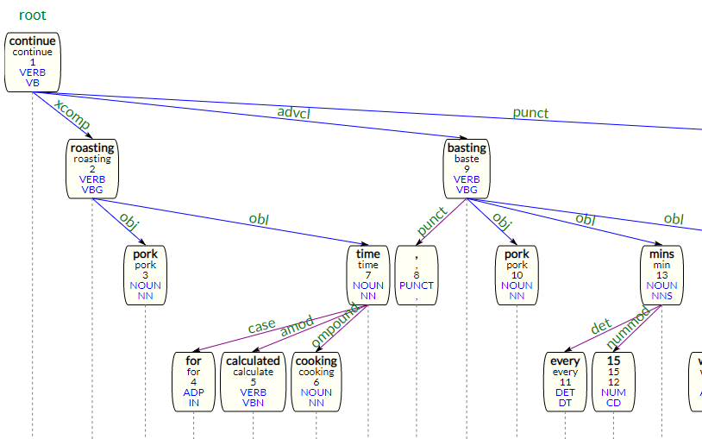

(25) remove pork from oven **when cooked .**

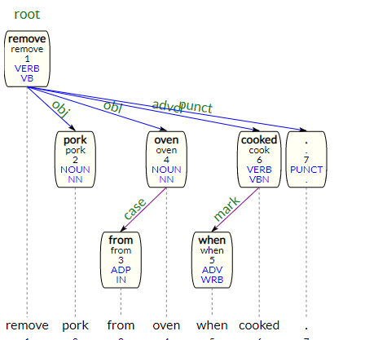

(29) cook **until thickened , strain .**

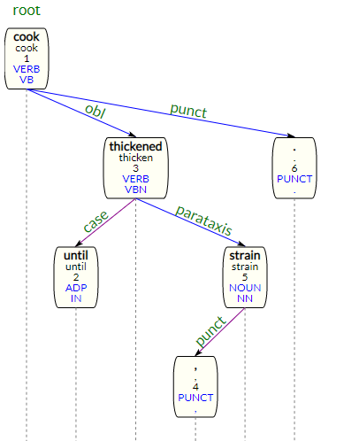

(92) micro-cook , **covered (acl)** , on 50 % power for 15 minutes , stirring twice .

